Phillip Pi’s 64-bit W7 EE SP1 (125% DPI) with its IE10 and Firefox v38.0.5 web browsers (default/normal zoom level) in http://hmt30.qa.webex.com on 6/15/2015 .
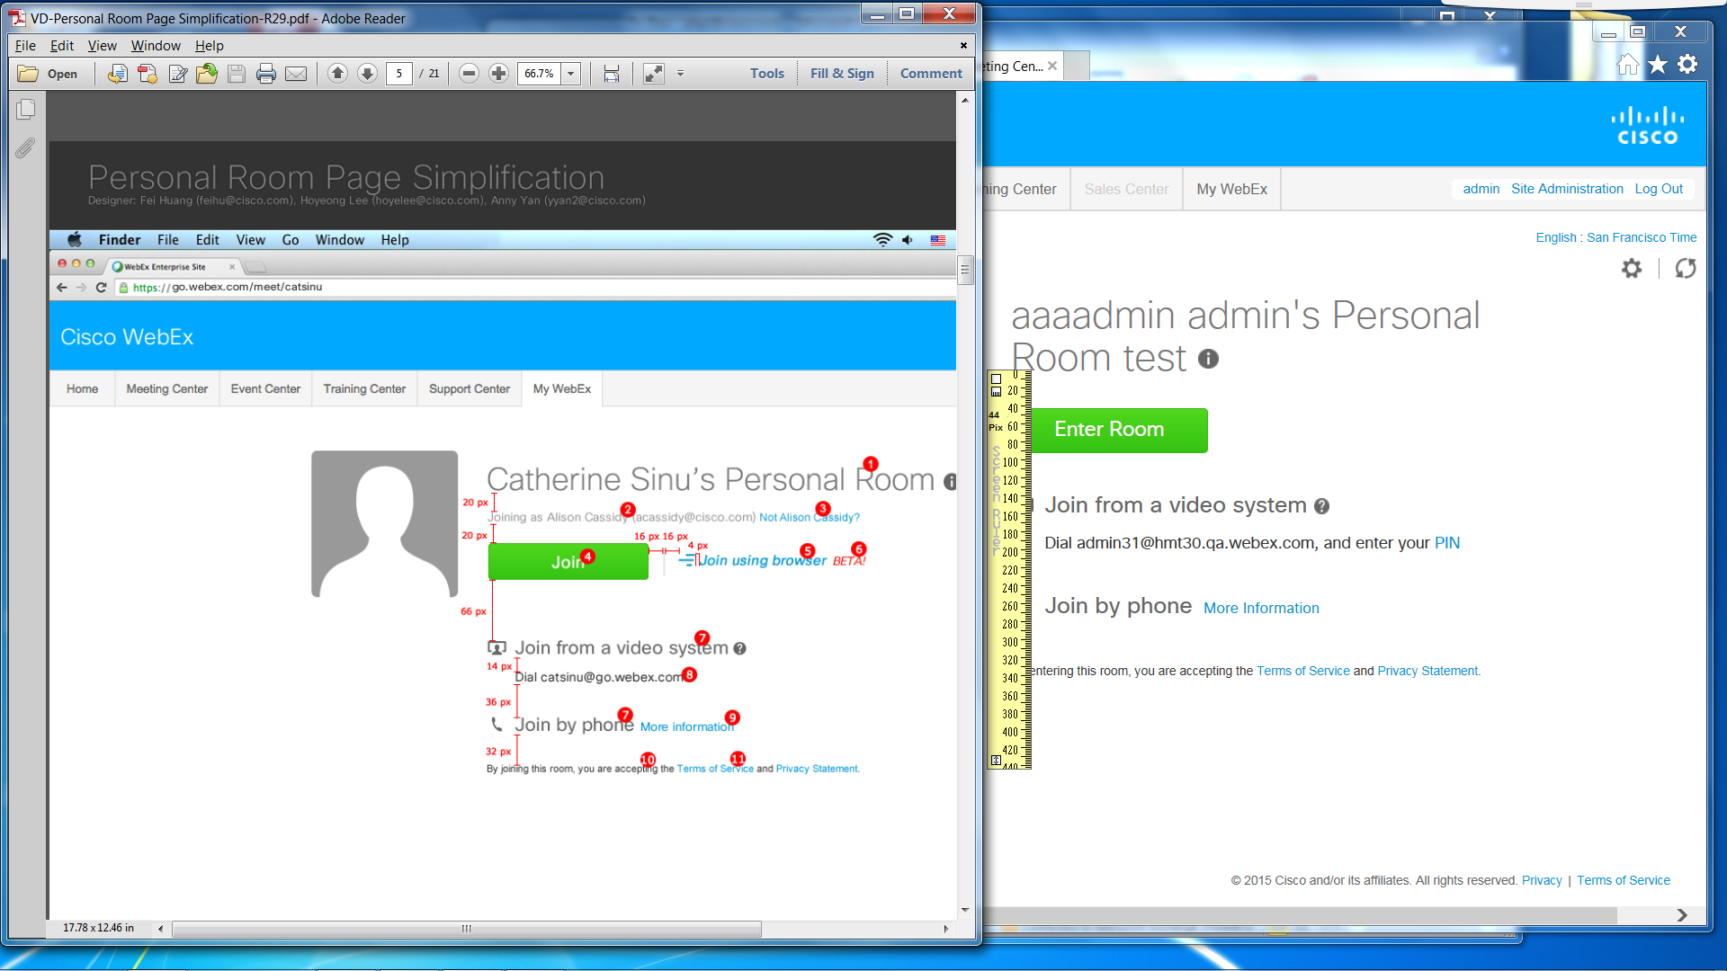
About 40 pixels gap even though there is no smaller text under Room title and different texts in the green button and right side has no texts and graphic. Below the green button is different pixel gap size. Seen in both IE and Firefox web browsers.
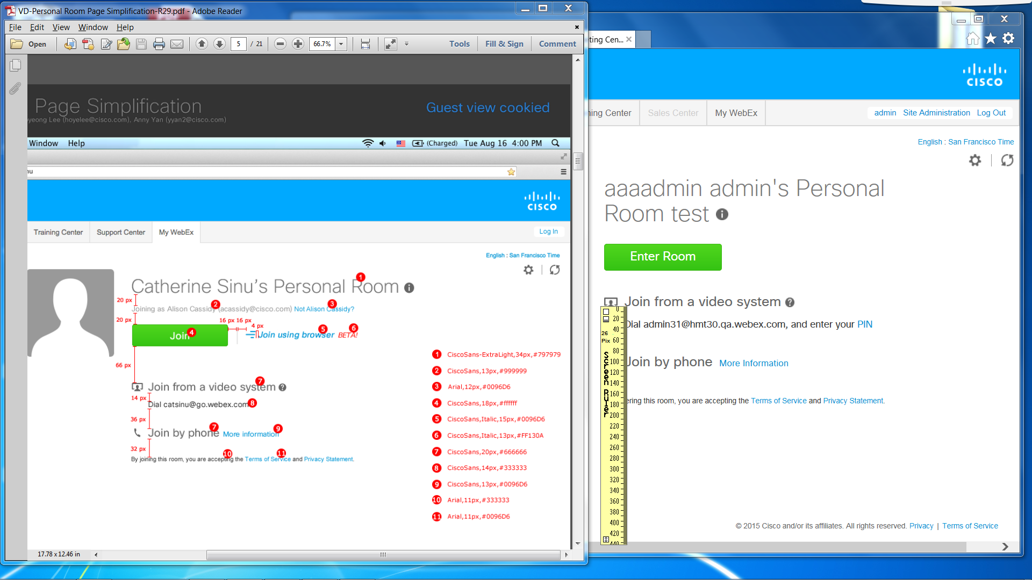
About 26 pixels gap between “Join from a video system…” and “Dial…” lines in IE. About 30 in Firefox with Dansk language.
About 50 pixels between “Dial…” and “Join by phone More information” lines. About 55 in Firefox with Dansk language.
About 60 pixels gap between “Join by phone…” and “… this room, you are accepting The Terms of Service and Privacy Statement.” lines in both web browsers.

Texts:
- IE: ~30 pixels tall. Developer tools show <h3 id="roomName" style="color: #797979; font-family: ciscosanstt_extralight; font-size: 34px; display: inline; max-width: 750px;">
Firefox: ~30 pixels tall. Source code shows <h3 id="roomName" style="display:inline;max-width: 750px;font-size: 34px;font-family: ciscosanstt_extralight;color: #797979;">
- IE: Not there.
- IE: Not there.
- Both showed different text, but is about 18 pixels tall. White text color, but couldn’t find #FFFFFF in the code and developer tools.
IE’s Developer tools showed <input name="enterRoom" class="btn btn-success big" id="mwx-btn-pmr-enter-room" style="width: 175px; height: 40px; font-family: ciscosansttregular; font-size: 18px;" onclick="Javascript:JoinNow()" type="button" value="Enter Room"/>
Firefox’s source showed style="font-family:ciscosansttregular;font-size:18px;width:175px;height:40px;" type="button">
- IE: Don’t have these texts and image.
- IE: Don’t have this text.
- Both were about 20 pixels high.
IE: <span style="color: #666666; padding-bottom: 14px; font-family: ciscosansttregular; font-size: 20px; display: inline-block;"> and <span style="color: #666666; padding-bottom: 6px; font-family: ciscosansttregular; font-size: 20px; display: inline-block;">
Firefox: <span style="display: inline-block;font-size: 20px;font-family: ciscosansttregular;color: #666666;padding-bottom:14px;">Deltag fra et videosystem and <span style="display: inline-block;font-size: 20px;font-family: ciscosansttregular;color: #666666;padding-bottom:6px;">Deltag via telefon&nbsp;</span>
- IE: About 11 pixels high. <p class="type-line" style="color: #333333; font-family: ciscosansttregular; font-size: 14px;">
Firefox: About 14 pixels high. <p class="type-line" style="font-size: 14px;font-family: ciscosansttregular;color: #333333;">
- IE: About 11 pixels high. <span id="mwx-p-audio-more-info" style="font-family: ciscosansttregular; font-size: 13px;">.
Firefox: <span id="mwx-p-audio-more-info" style="font-family: ciscosansttregular;font-size:13px;">
Could not find the specific code with this color code. Color looks correct though.
- Slightly different texts, but look correct with about 10 pixels height. Could not find Arial font in developer tools and source code.
IE: <p class="crm-text" style="font-size: 11px; margin-top: 32px;">.
Firefox: <p class="crm-text" style="font-size: 11px;margin-top: 32px;">
- Both web browsers: It looks correct with about 10 pixels height and Arial font, but I could not find Arial font in developer tools and source code.
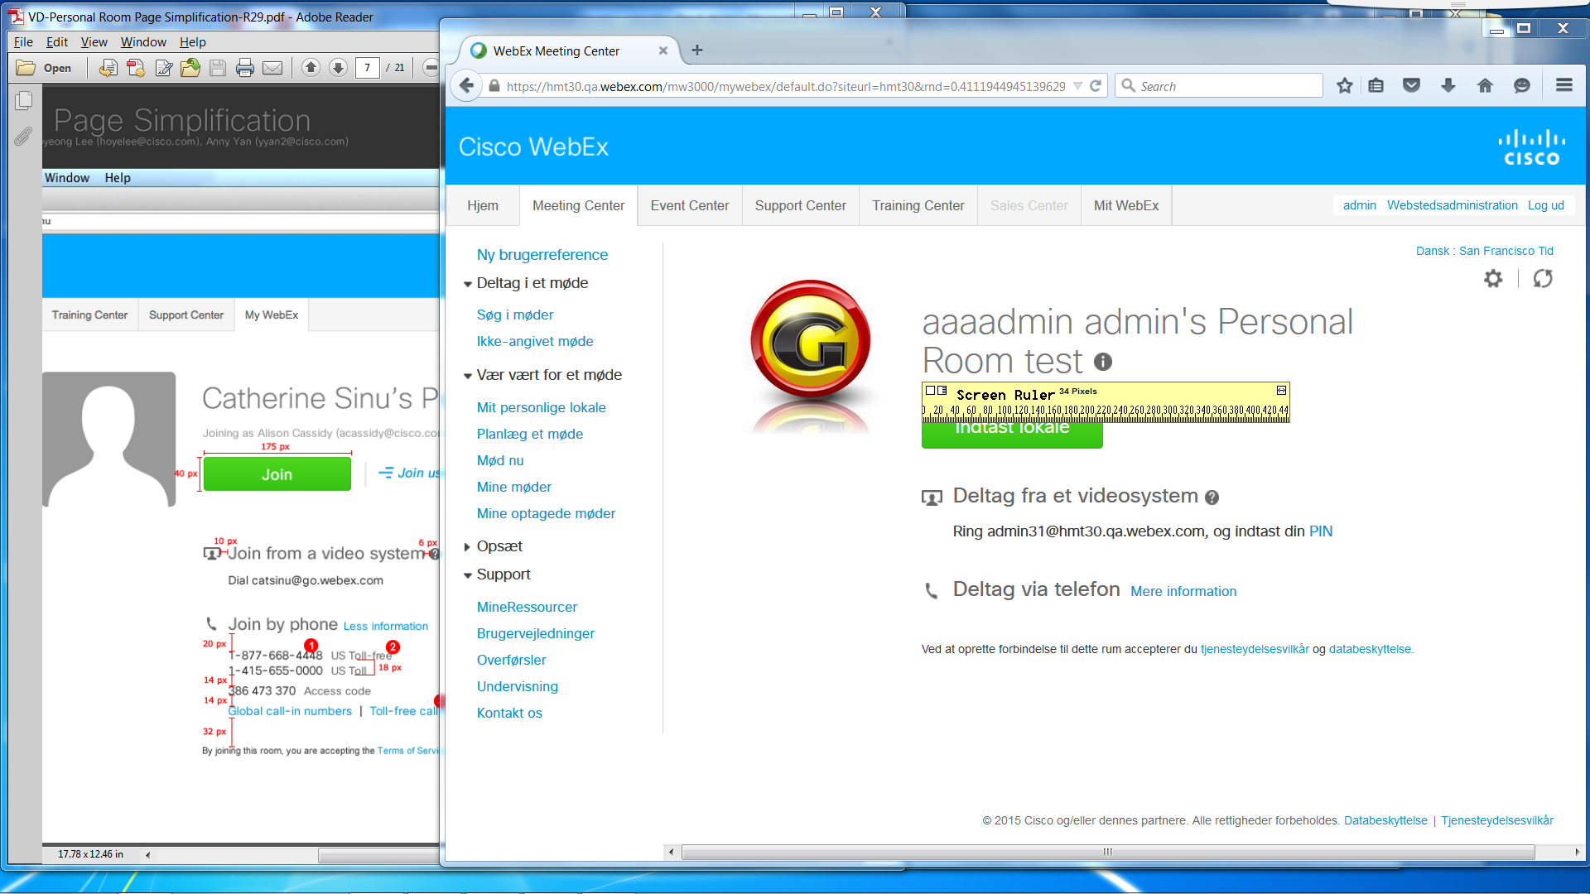
About 220 pixels wide in both web browsers.
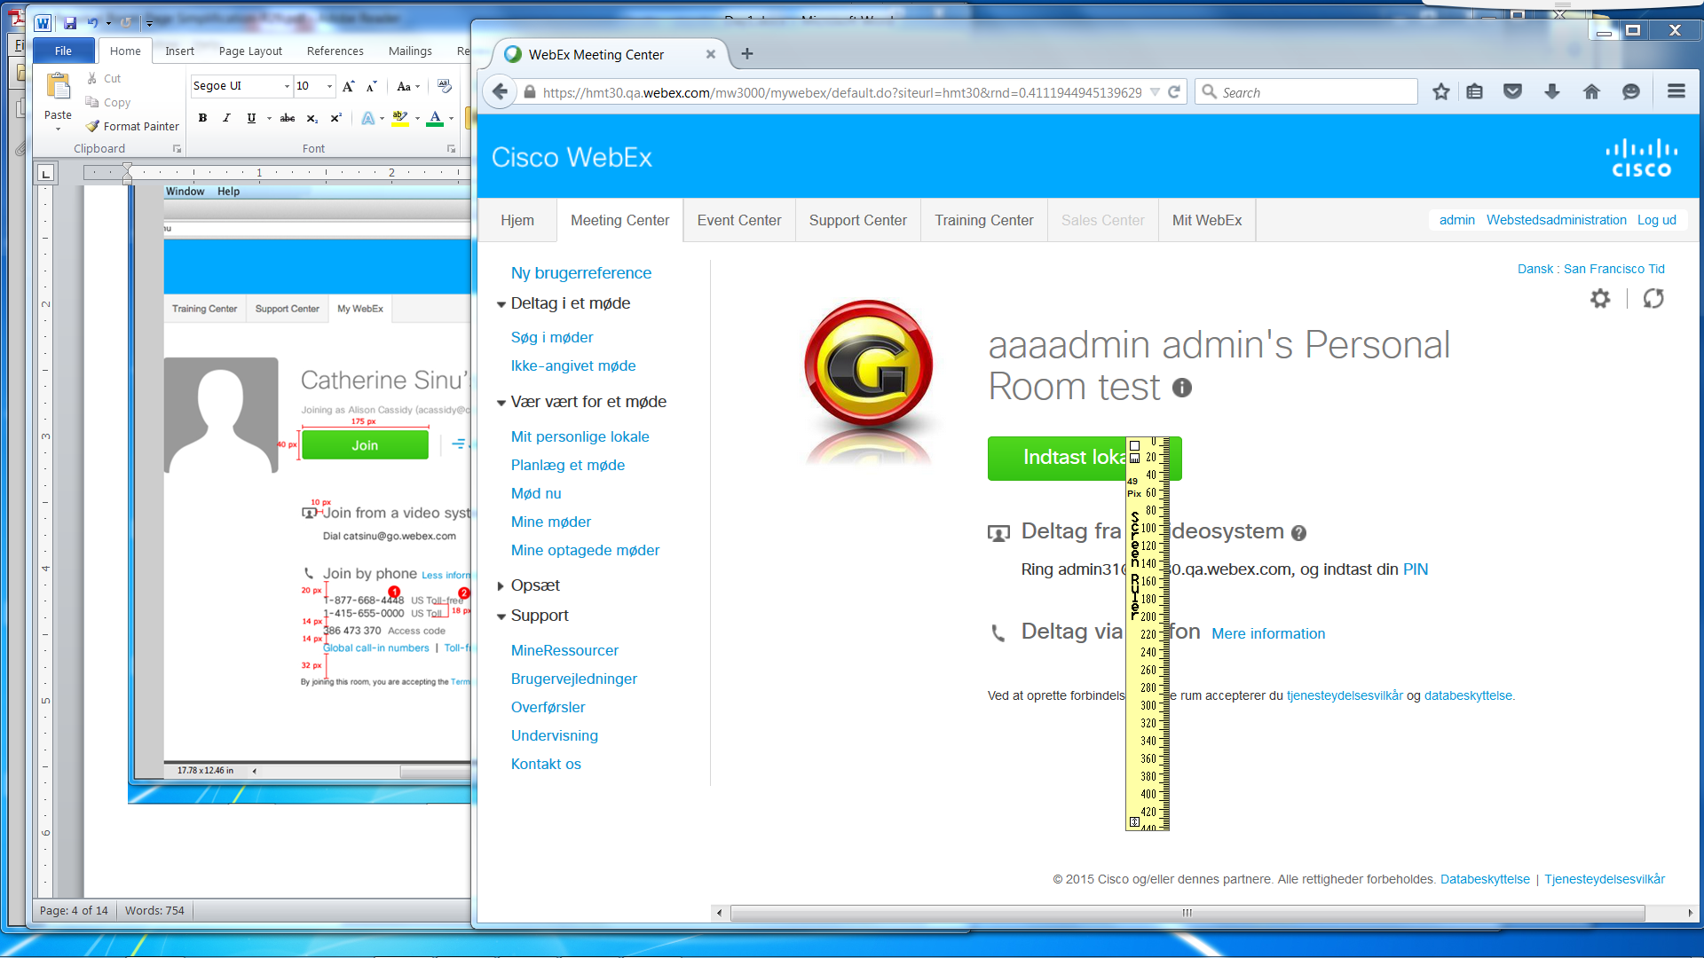
About 49 pixels tall in both web browsers.
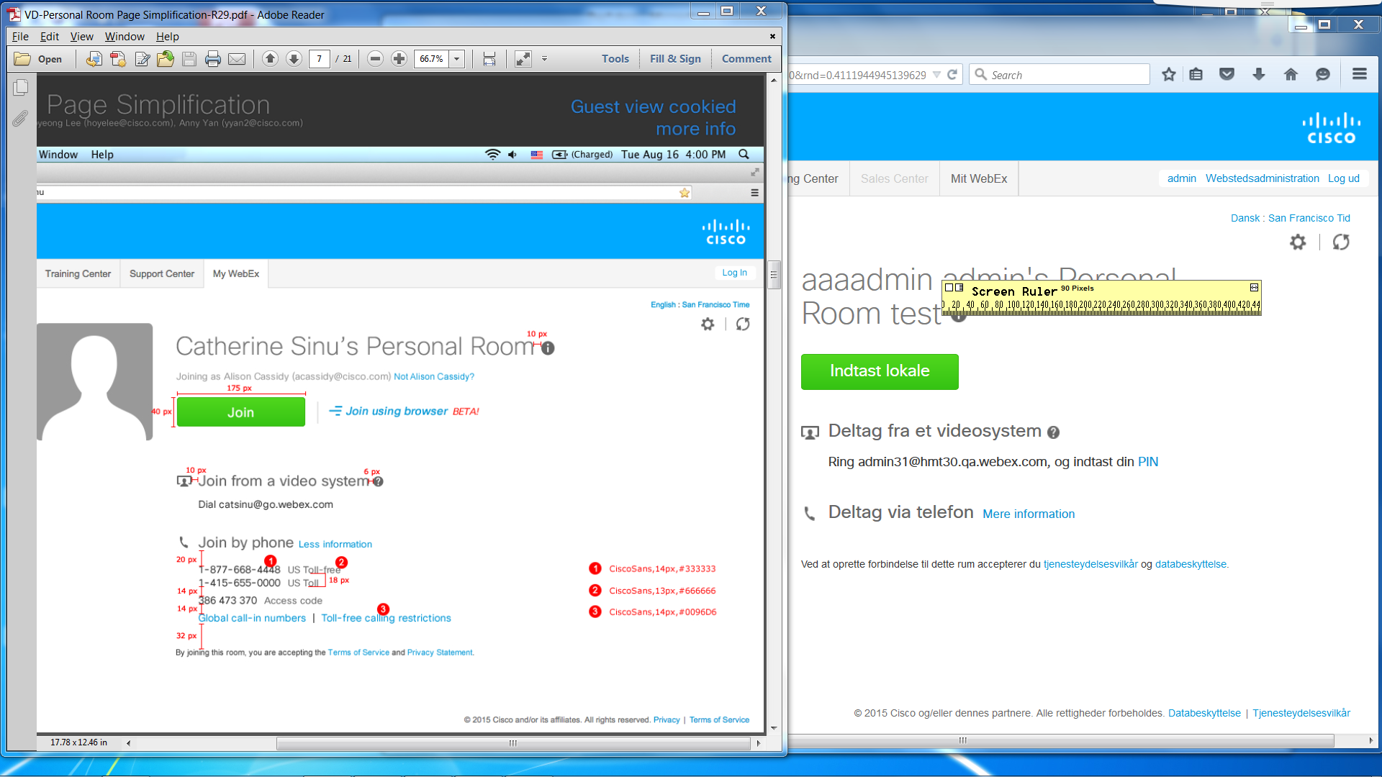
About 13 pixels in both web browsers.

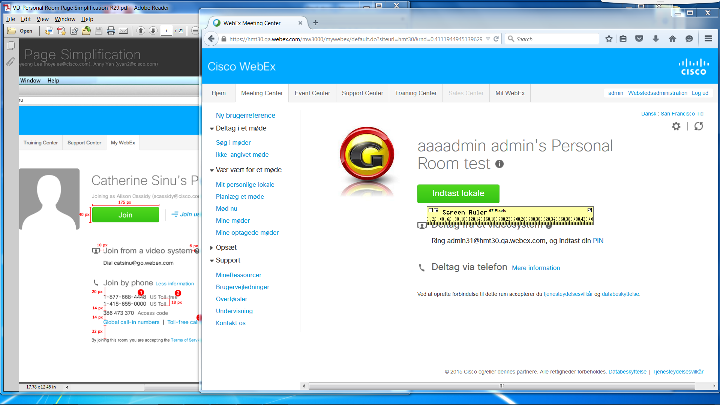
About 15 pixels in both web browsers.

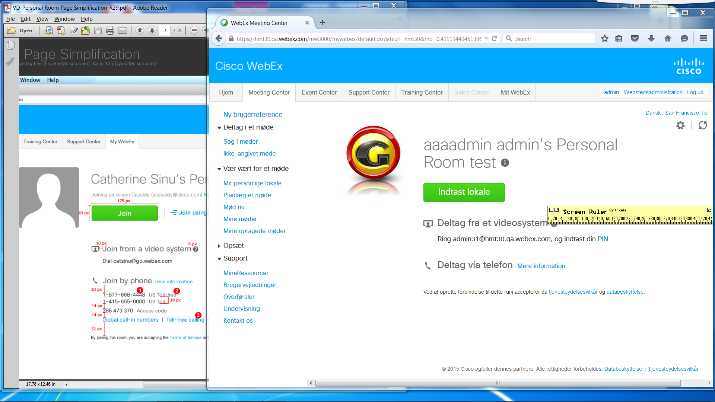
About 10 pixels in both web browsers.

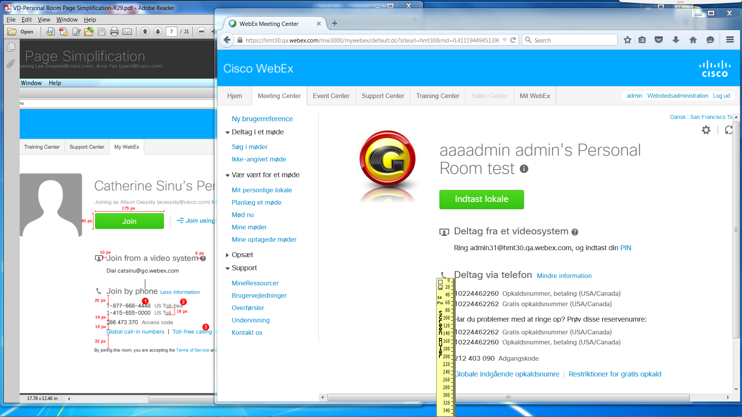
About 33 pixels in Firefox and about 28 pixels in IE.

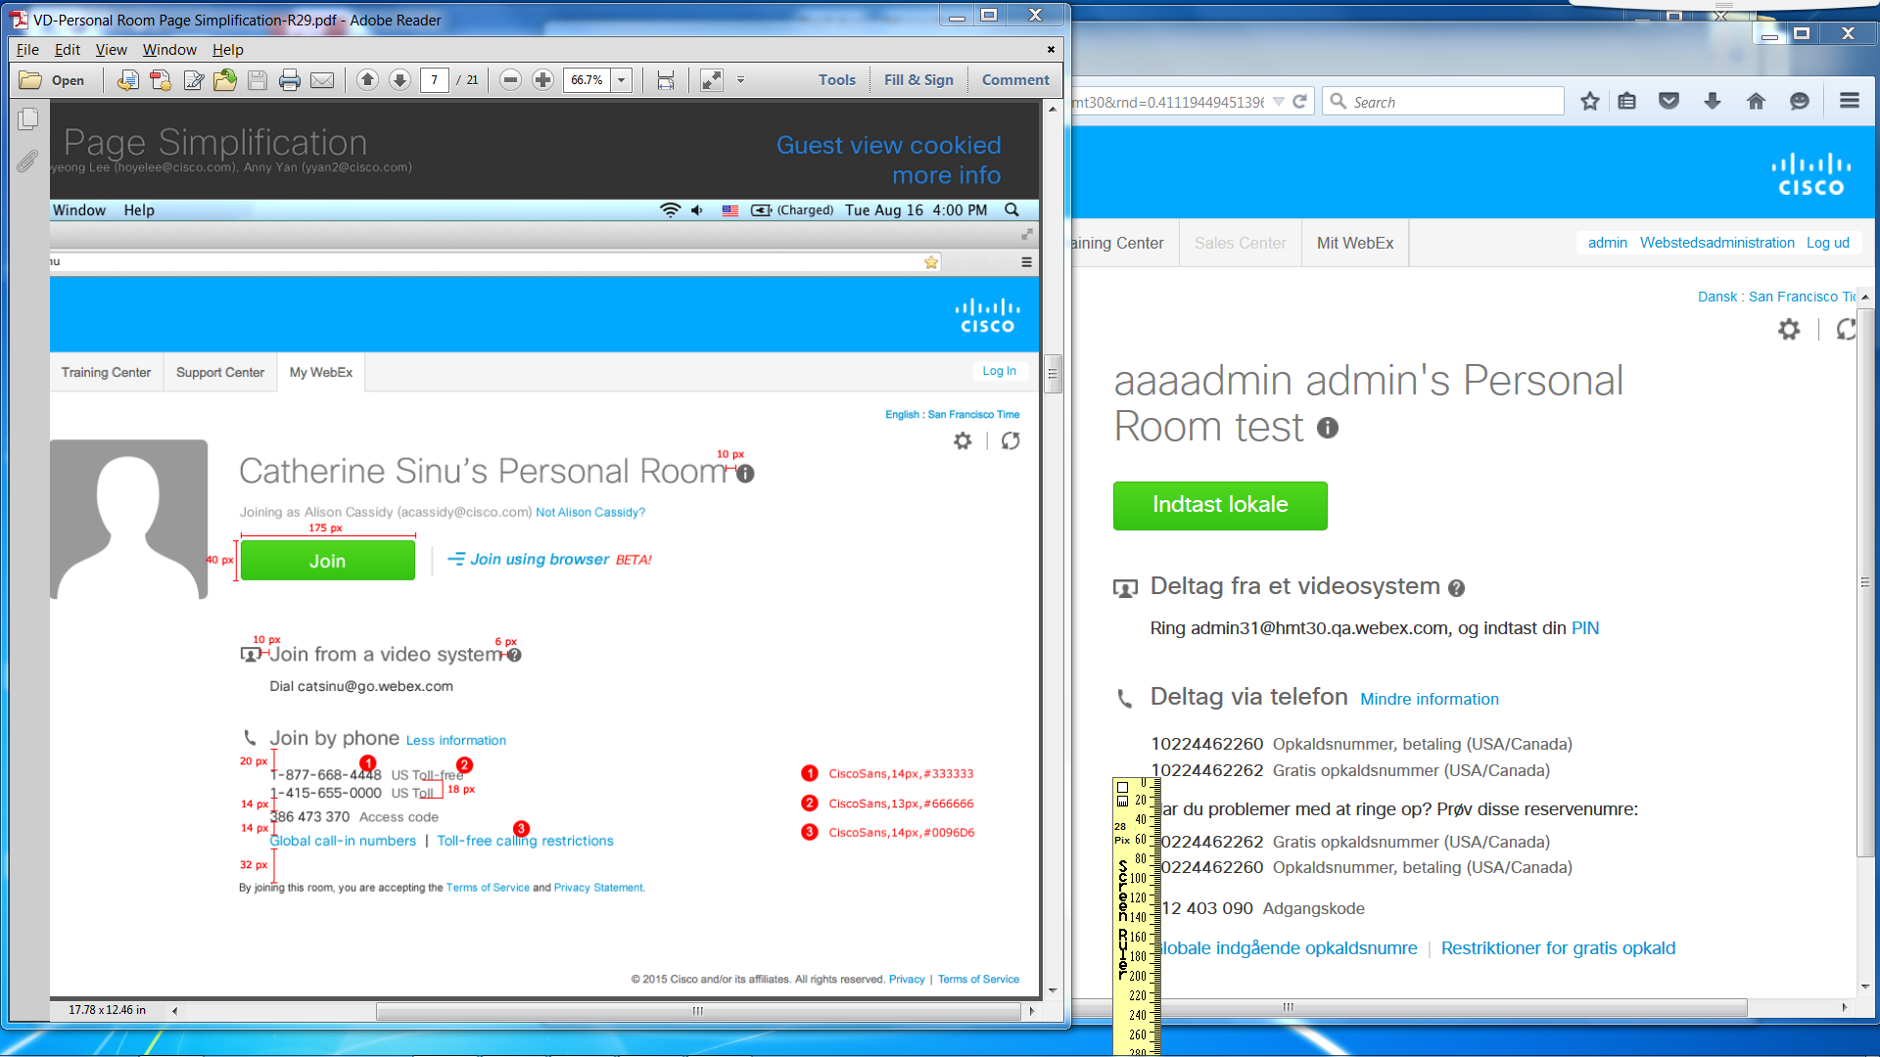
About 28 pixels in Firefox and about 33 pixels in IE.

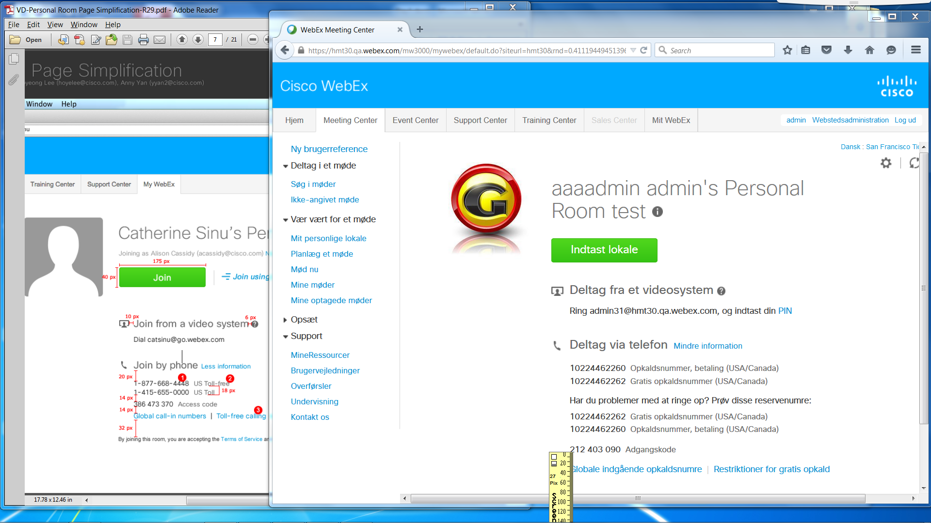
About 27 pixels in both web browsers.

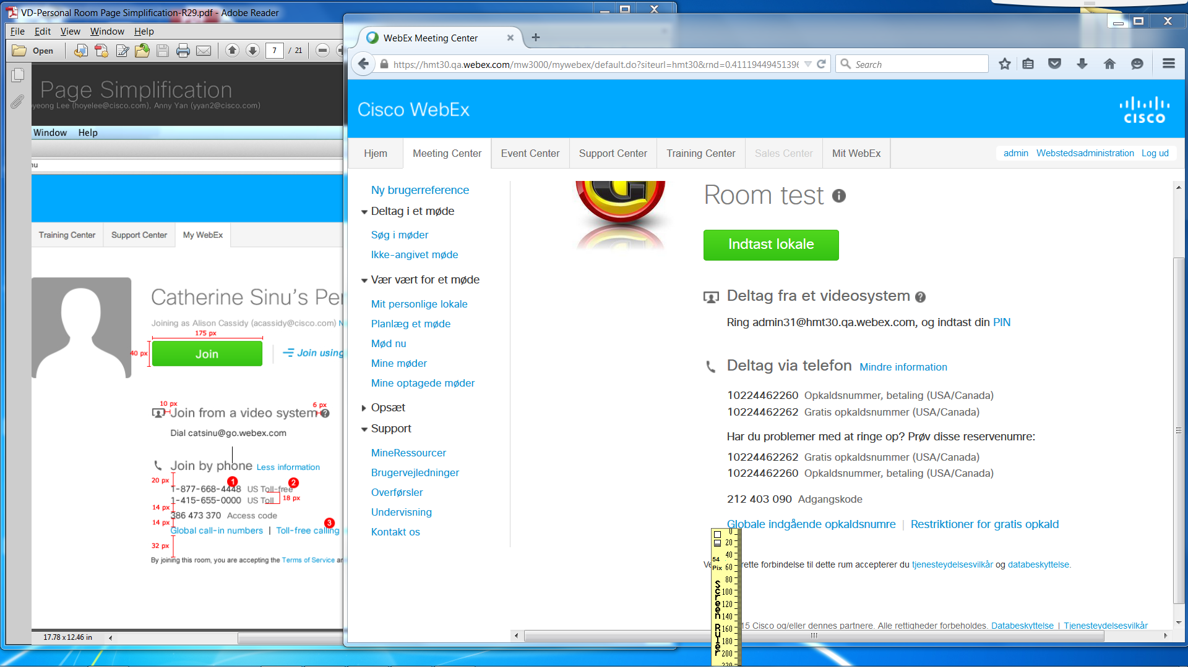
About 54 pixels in both web browsers.

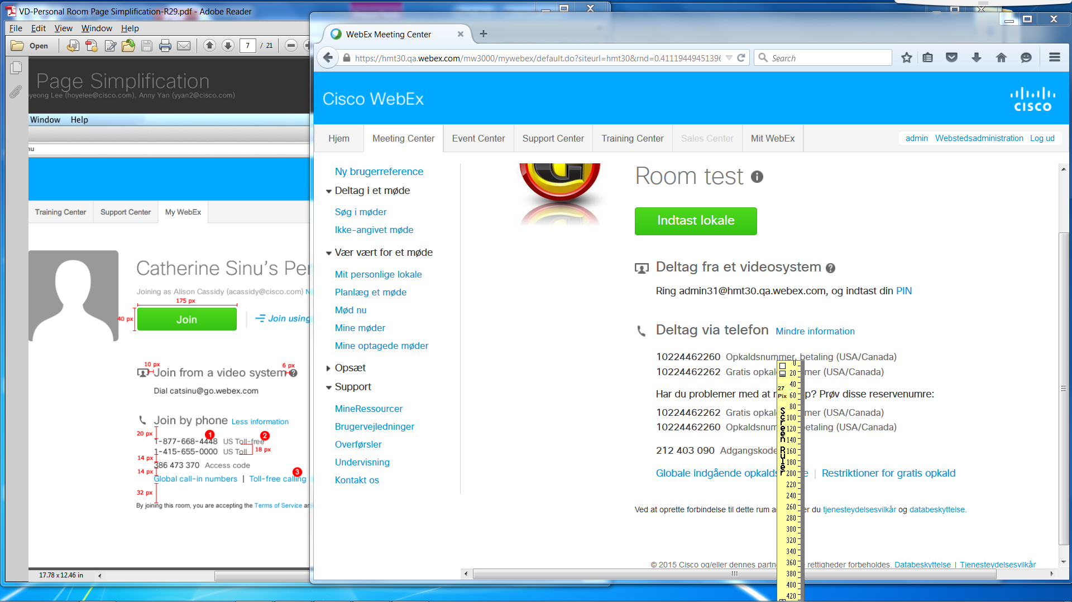
About 27 pixels in both web browsers.

Texts:
- Firefox: About 12 pixels tall. <span style="font-family:ciscosansttregular;font-size:14px;color:#333333;">10224462260</span>
IE: About 11 pixels tall. <span style="color: #333333; font-family: ciscosansttregular; font-size: 14px;">
- Firefox: About 12 pixels tall. <span style="font-family:ciscosansttregular;font-size:13px;color:#666666;">&nbsp;Opkaldsnummer, betaling (USA/Canada)</span>
IE: About 11 pixels tall. color: #666666; font-family: ciscosansttregular; font-size: 13px;
- Firefox: About 12 pixels tall. <span><a style="font-family:ciscosansttregular;font-size:14px;color:#0096D6;" id="mwx-lnk-cmr-toll-free" href="http://www.webex.com/pdf/tollfree_restrictions.pdf" target="_blank">Restriktioner for gratis opkald</a>
IE: About 11 pixels tall. <a id="mwx-lnk-cmr-toll-free" style="color: #0096d6; font-family: ciscosansttregular; font-size: 14px;" href="http://www.webex.com/pdf/tollfree_restrictions.pdf" target="_blank">

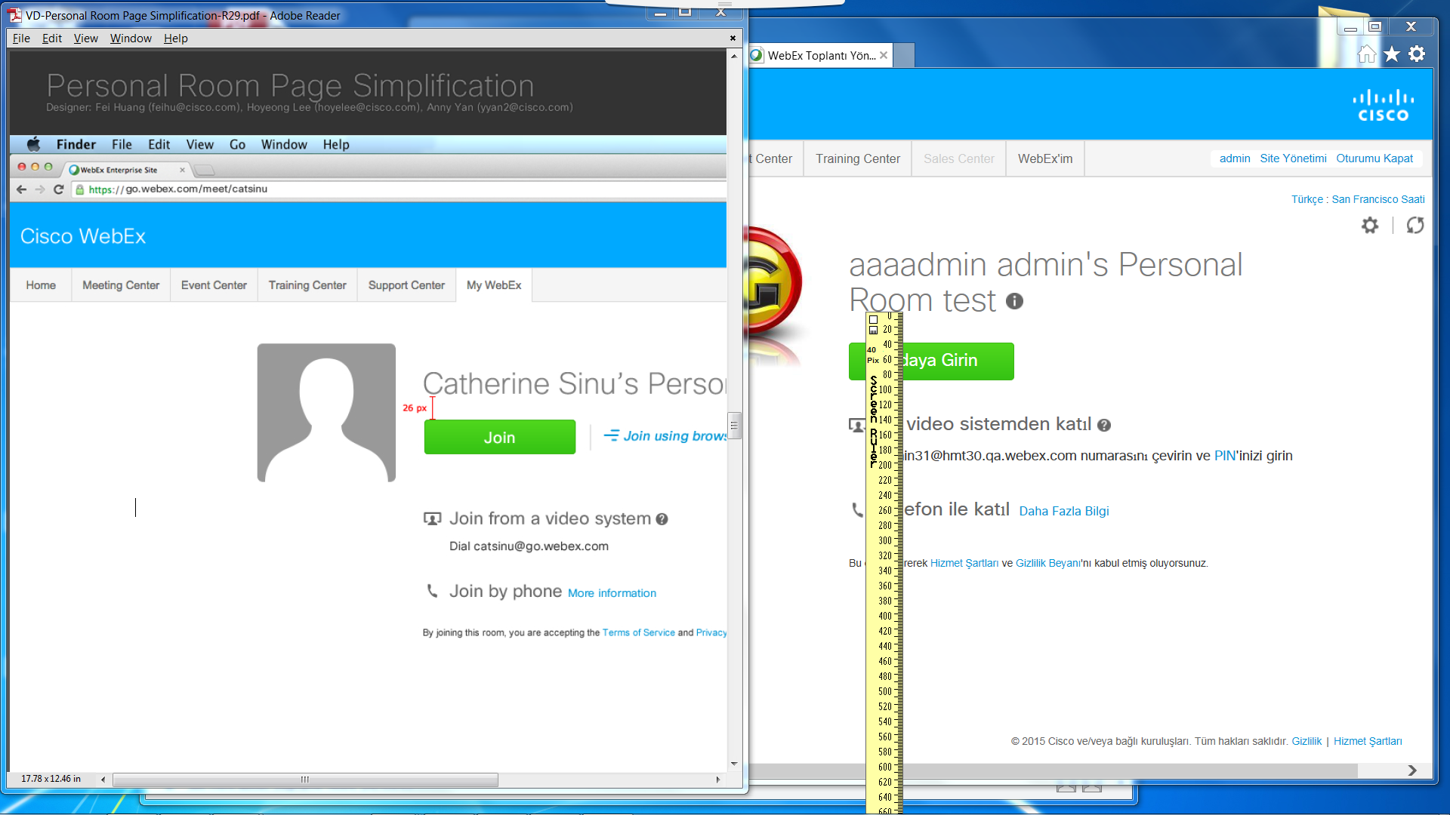
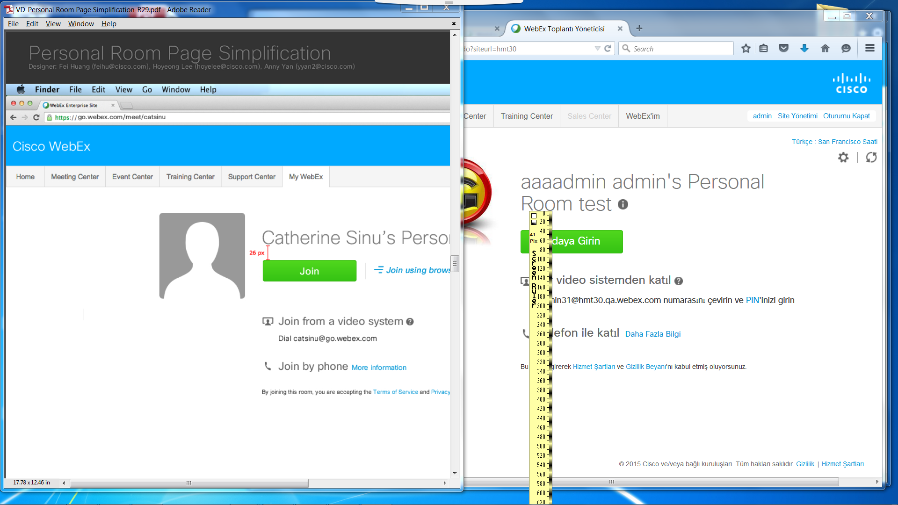
Both were about 40 pixels in both web browsers between name and “Join” button.

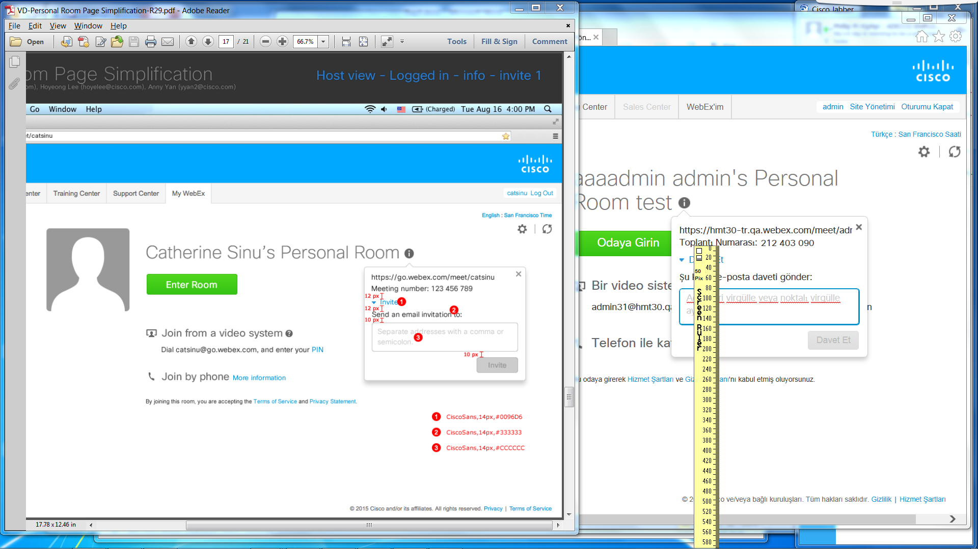
About 20 pixels in both web browsers for meeting information and blue expanded “Invite” link.

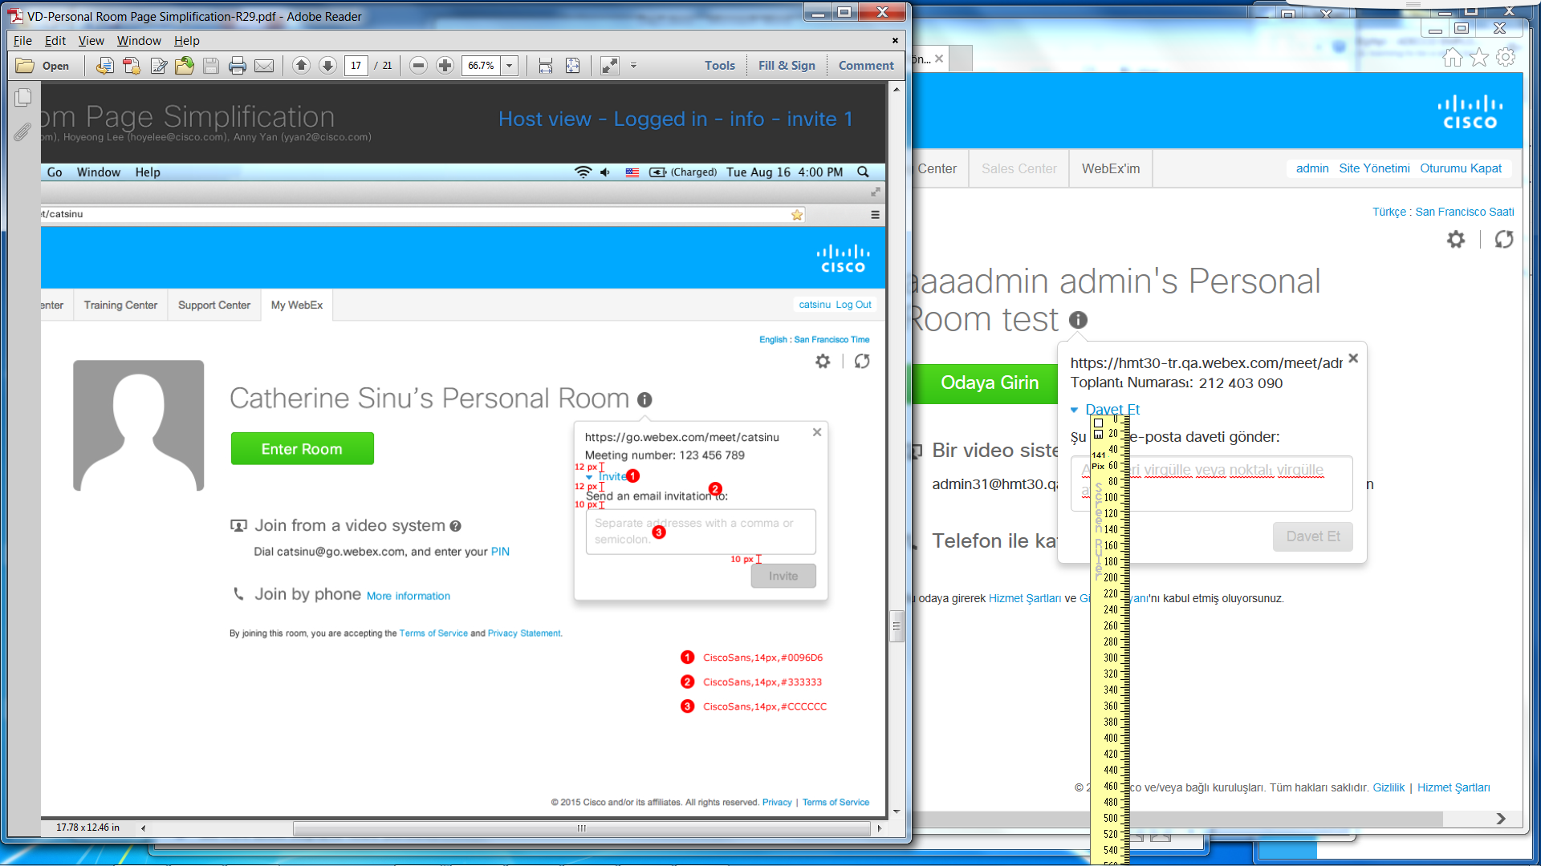
About 23 pixels in both web browsers between the blue expanded “Invite” link and “Send an email invitation to:”.

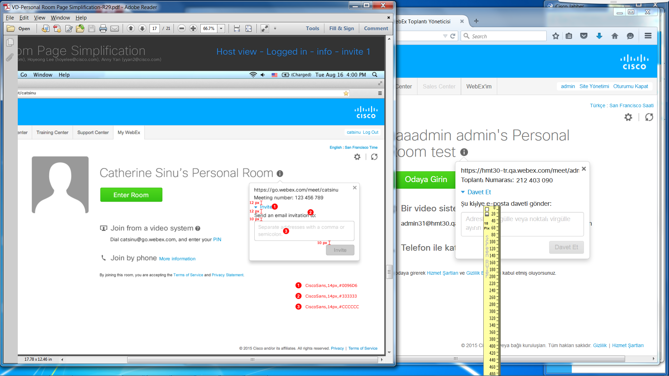
About 18 pixels in both web browsers between “Send an email invitation to:” and the form box.

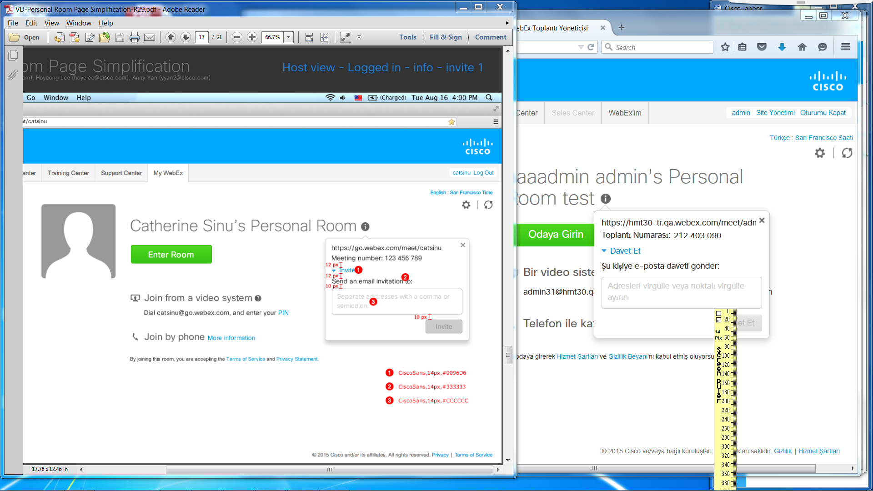
About 14 pixels between form box and “Invite” button in both web browsers.

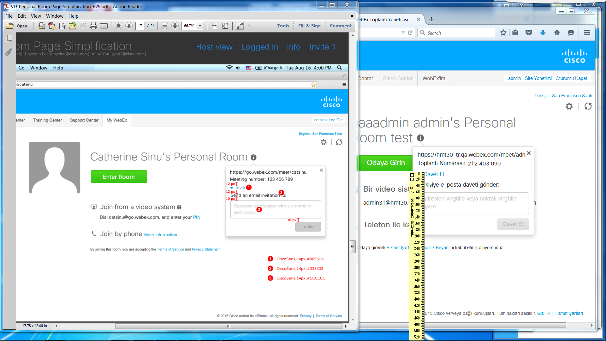
- Blue Invite link’s font size:
Firefox shows about 13 pixels tall. HTML code says “font-family:ciscosansttregular;font-size: 14px;color:#0096D6;”.
IE10 shows about 14 pixels tall. Developer tools show <span style="color: #0096d6; font-family: ciscosansttregular; font-size: 14px;">
- “Send an email invitation to:”:
Firefox shows is about 13 pixels tall (excluding tails like in s and y). HTML code text style="font-family:ciscosansttregular;font-size: 14px;color:#333333;margin-bottom: 10px;">
IE10 shows about 15 pixels tall. Developer tools show <div class="form-group" id="invite-title" style="color: #333333; font-family: ciscosansttregular; font-size: 14px; margin-bottom: 10px;">
- Form’s texts:
Firefox shows about 14 pixels tall. HTML code shows style="font-family: ciscosansttregular; width: 282px; height: 56px; resize: none; color: rgb(204, 204, 204);">Adresleri virgülle veya noktalı virgülle ayırın</textarea>. RGB values match CCCCCC hexadecimals.
IE10 shows about 15 pixels tall. Developer tools show <textarea class="form-control" id="mwx-area-invites" style="width: 282px; height: 56px; color: #cccccc; font-family: ciscosansttregular;" onfocus="enterInput(true);" onblur="enterInput(false);" rows="2">

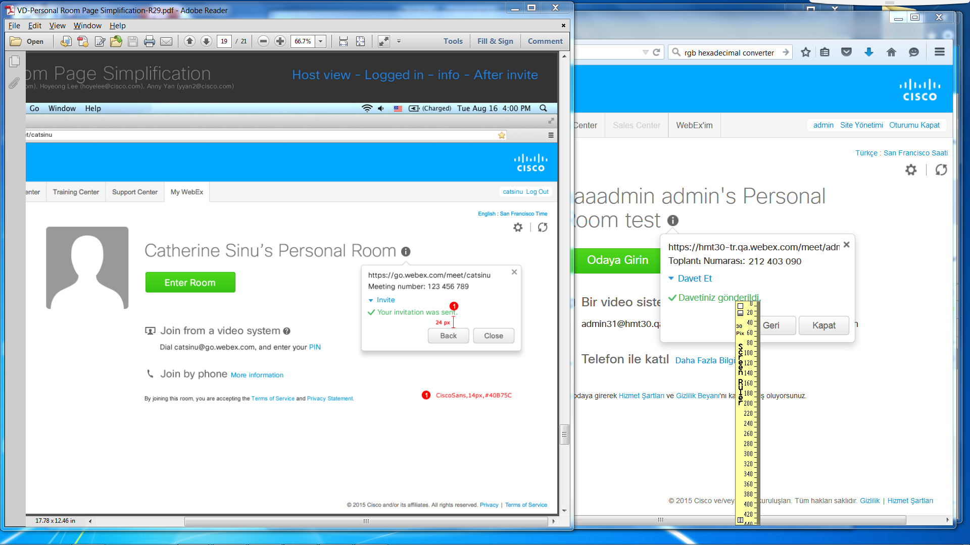
About 30 pixels between “Your invitation was sent.” And “Back” button.

“Your invitation was sent.”’s height font size is about 13.
Firefox’s HTML code shows “<span class="pass">?</span></span><span style="font-family:ciscosansttregular;font-size: 14px;color:#40B75C;">Davetiniz gönderildi.</span>“
IE10’s developer tools show <span style="color: #40b75c; font-family: ciscosansttregular; font-size: 14px;">

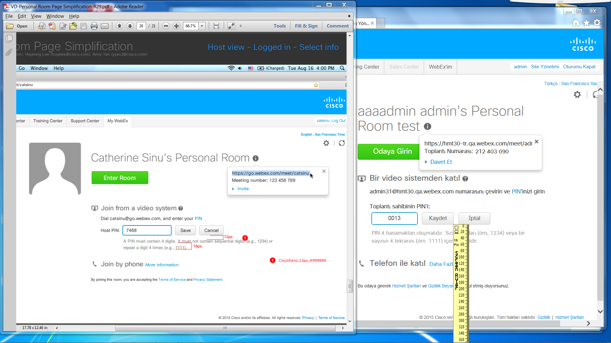
Between the Cancel button and PIN instructions, there are about 20 pixels of spacing in both web browsers.

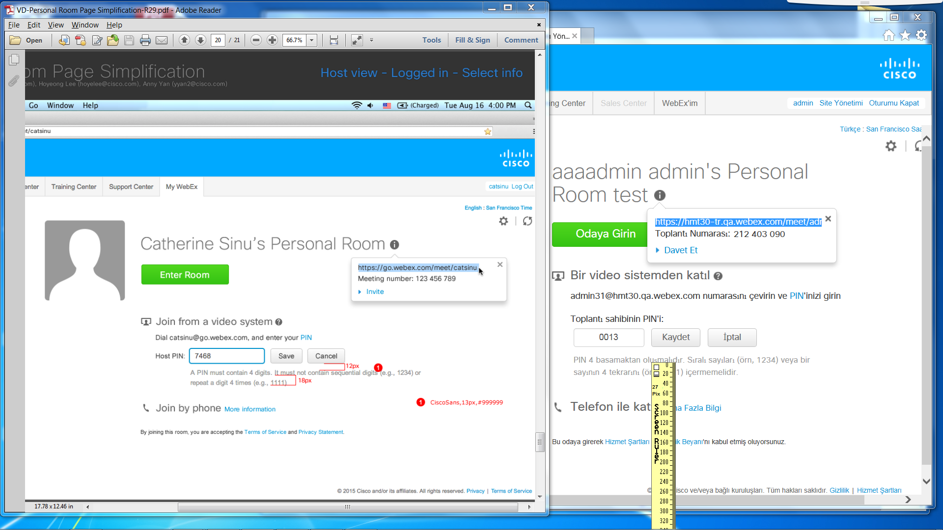
There are about 26 pixels between the bottoms of each line for PIN instructions in both web browsers.

IE10’s developer tools showed <p class="type-line type-help" id="mwx-tip-hostPIN" style="font-family: ciscosansttregular; font-size: 13px; margin-bottom: 0px;"> and #999.
Firefox’s source code and inspected element showed <p class="type-line type-help" id="mwx-tip-hostPIN" style="margin-bottom:0px; font-size:13px;font-family:ciscosansttregular;">PIN 4 basamaktan oluşmalıdır. Sıralı sayıları (örn, 1234) veya bir sayının 4 tekrarını (örn. 1111) içermemelidir.</p> and #999.

